**2D-Adversarial Games Analysis**

Adversarial games form a key part to multiplayer experiences and have few broad characteristics define them, a game's participants may be referred to as agents. This however doesn't limit the fact that adversaries can be AI that perform player-like actions to simulate a multiplayer scenario. Good early examples of these are computers that solely developed for certain board games such as chess. Deep Blue was developed by IBM and defeated reigning chess champion Garry Kasparov in a rematch in 1997 under regular rules making it one of the most formidable early AI. There have been earlier AI developments, as early as 1952, however the first-viewed game using AI was Pong that was developed in 1972.

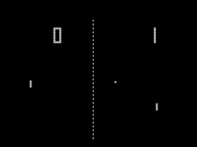

Pong, created in 1972, demonstrated clever AI in its time (Image link: https://goo.gl/VBRS5B)

Steering away from AI, players can compete against each other following a set of rules and developing strategies to make use of the game's rules to their advantage. Players can also cooperate as teams to attain victory over an opposing team. It is common then that players achieve a sense of 'fiero' when they beat their opponent that stimulates the effect of 'challenging fun'.

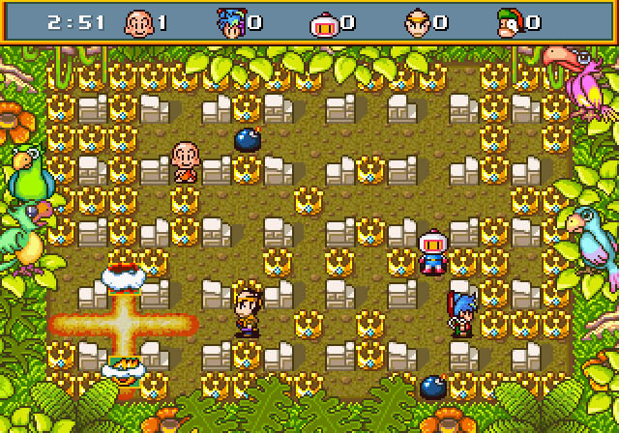

Saturn Bomber was released in 1997 and could host up to ten players simultaneously (Image link: https://goo.gl/103GMu)

Adversarial games can be played either in real time where players can perform actions simultaneously that ultimately conflicts or synergises with each other or use a turn-based feature where players make meaningful choices to maintain an advantage over their opponents. Very often, players will not make optimal choices which lengthen the time of play in the game. Adversarial games enhance what's called 'competitive' play however they can also form 'cooperative' play i.e. teams versus teams.

Notable games include early release of Mortal Kombat and Street Fighter which dominated arcade games in in the early 90's as two players would be given a set of controls to use different types of attacks against their opponent and more importantly concoct combinations for a more focused experience.

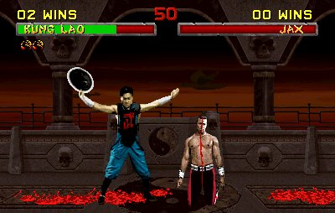

Mortal Kombat took arcade gaming by a storm providing intense (and gory) fighting action. (Image link: https://goo.gl/q8AtuZ)

Many games, particularly in the MMO, shooter and sports genres, adopted adversarial features through a Player-Versus-Player system where players either fought solo or in a team against others. Prime examples of these are Smite (played in teams of 5 vs. 5), FIFA series (which hosts a myriad of intense one-on-one's) and the Call of Duty trilogy where players assume the mantle of military operatives to form teams or battle it out free-for-all, adding high-octane action to player's experiences.

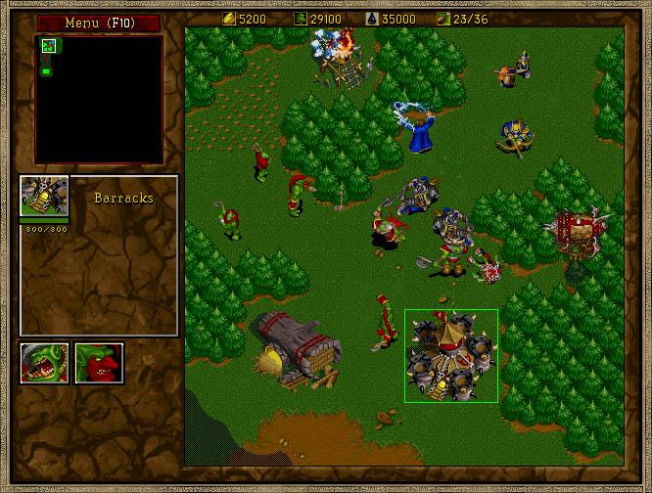

Warcraft 2 was a real-time strategy base game which relied on tactical thinking when attacking and defending. (Image link: https://goo.gl/IH9M9Z)

**Reference Materials**

Coleman, S. (2014). 20 Most Competitive Video Games Of All Time. Available: http://whatculture.com/gaming/20-competitive-video-games-time?page=21. Last accessed 28th Jan 2017.

Museum of the Game™. (1995). Mortal Kombat II. Available: http://www.arcade-museum.com/game_detail.php?game_id=8756. Last accessed 28th Jan 2017.

Schulte, O. (2011). *Adversarial Search and Game-Playing.* Available: http://www.cs.sfu.ca/CourseCentral/310/oschulte/mychapter5.pdf. Last accessed 27th Jan 2017.